Factory Audit Report

PRODUCTION DATA
From: | Email:
GENERAL INFORMATION
Buyer:
Manufacturer:
Product Description:

Different country cord and cable specification
Audit Location:
Audit Date: Any work time is ok

SUMMARY
- This factory mainly manufactures:
Different plug and different cable specification
2. We have many certifications for different countries in the world, and we have PVC, Rubber cable, BQ cable for different demand from customer, we cooperation with many famous companies in the word, like Panasonic, Bosch, Karcher, Elica and so on.
3. The factory passed ISO9001 and iso14001

Supplier REGISTERED Information
Supplier Name:
Registered Address:
Current Address:
Registered Capital:
Type of Ownership: Foreign capital
Year Established: 2004

Supplier CONTACT Information
Contact Person:
Job Title:
Phone Number:
Email:
Web address:

Supplier BUILDING Information
According to:
Total land size: 15000 Square meters
Work shop Size: 6,000 Square meters

SECTION 01 |  | LEGAL VALIDITY
 | Does the company have a valid business license: yes
 | Registration Number:
 | Is the annual review done by local authority (Industrial & Commercial Bureau): yes
 | Name of corporative representative:
 | Products Manufactured / Sold Scope:
 | Does the company have a valid EXPORT license:
 | Nearest port:

SECTION 02 |  | CERTIFICATIONS
2.1 | QUALITY MANAGEMENT System Certificate
 | Certification |  | Certifying Body | Number | Expiry Date | Scope
 | ISO 9001:2015 |  | CQC |  | 9TH May.2019 | Power cord
 | ISO 14001:2015 |  | CQC |  | 8TH April.2020 | Power cord
CERTIFICATES PICTURES ATTACHMENT
Business License
ISO14001 certification

SECTION 03 |  | HUMAN RESOURCES
3.1 | Company Chart
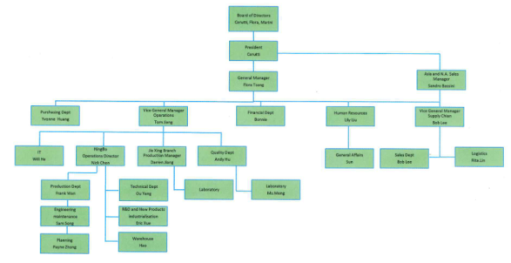
3.2 | Explanation of employee details
 | Department Name |  | Headcount
 | Office staff
 | Worker
 | Sales
 | Finance
 | Production control
 | Purchaser
 | Administrator
 | QC
 | Number in TOTAL : |  | 273
3.3 | Training Plan
 | Training Procedure and plan for staffs: Yes
 | Are there uniforms for all staffs in company? : Yes
3.4 | China Labor
 | Do you follow the China Labor Law? : Yes
 | No Child Labor? : Yes

SECTION 04 |  | BUSINESS MARKET
4.1 | Basic Situation
 | Ranking in Chinese Market: The top three of manufacturing: Power cord is used for Electric tool, water pump, small appliance, cleaning machines and so on.
 | The annual revenue in last two years:
 | Estimated revenue in this year:

4.2 | Main Export Market
 | Market Area: Percentage of Total Business Volume (Last Year)
 | Domestic: 11%
 | Abroad: 89%

4.3 | TOP 3 Overseas Customers
 | Customer Name | Industry | Percentage of Total Sales | Methods
 | Makita Japan |  |  | Sell directly
 | BOSCH |  |  | Sell directly
 | Karcher |  |  | Sell directly

4.4 | TOP 3 European Customers, Please specially specify customers in Europe market
 | Customer Name | Industry | Percentage of Total Sales | Methods
 | BOSCH | Electric tool | 20% | Sell directly
 | Karcher | Cleaning machine mamachimachine | 14% | Sell directly
 | Elica | Home appliances | 3% | Sell directly

4.5 | Do you attend any EXHIBITIONS in and out of China regulary each year? If yes, please specify.
 | No

4.6 | Products of Export
 | Type of Product: Percentage of Total Business Volume (Last Year)
 | Power cord 89%

SECTION 05 |  | PRODUCTION CAPACITY LAST YEAR
5.1 | Products Situation
 | Product Description / Category |  | Average Production Capacity (Daily)
 | Power cord |  | 260000 Meters
 | Plug |  | 85000pcs

5.2 | Main Facilities
 | Facility Name | Brand/Model | Quantity | Status | Remarks
 | Plug injection machine | 55TC | 22 | good
 | Plug vertical injection machine | 35TC | 5 | good
 | Automatic Insulation machine | 60,50 | 5 | good
 | Automatic Insulation machine | 75+35 | 2 | good
 | Automatic jacket machine | 90 | 2 | good
 | Automatic jacket machine | 80+25 | 2 | good
 | Semi-automatic terminal machine |  | 25 | good
 | Automatic terminal machine |  | 5 | good

5.3 | Main Test Instruments
 | Instrument Name | Brand/ Scification | Quantity | Status
 | Plug tester | HD-208 | 24 | good
 | Withstand voltage tester | GT910028 | 1 | good
 | Insulation Resistance Tester | 19366 | 1 | good
 | Pulsing test machine | 07116548 | 1 | good
 | Scorching test machine | 08111099 | 1 | good
 | Four position bending test machine | 09070543 | 1 | good
 | Roller tester | PCNB-T-05-GC-001 | 1 | good
 | Specific-gravity balance | 2002-00047 | 1 | good
 | Shore hardness tester | F28-503300004 | 1 | good
 | Air changing aging tester | 12121706 | 1 | good
 | Salt mist test machine | DG-16349 | 1 | good
 | Low temperature winding test machine | 2002-00053 | 1 | good
 | Single wire vertical flame tester | 11050530 | 1 | good

SECTION 06 |  | QUESTIONNAIRE
6.1 | Management Supplier answer
 | Our goal is to support our customers starting from product development till final approval as quickly and efficiently as possible, guaranteeing them with immediate productivity and long-term quality advantages.
Is the organization structure focused on markets /segments, customers, technologies, products? Yes
technologies, products?
:
Marketing and production
 | What is the long term objective for the business relation with Client?：High quality ,excellent service
 | Are there ISO / environmental certificates？：YES
 | Is a training program available?：YES

SECTION 07 | PRICING（价格）

7.1 | Price Conditions
 | Minimum Order Quantity :
 | FOB or CIF preferred?:
 | Currency accepted? Which is the preferred? :
 | Condition of Prices :

SECTION 08 | FACTORY PICTURES

Laboratory
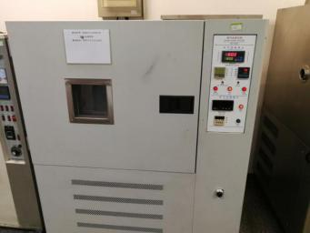 | 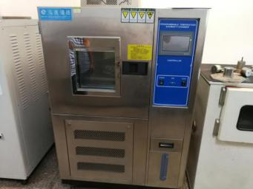
Aging oven tester（换气式老化机） | Constant temperature and humidity tester（恒温恒湿试验箱）
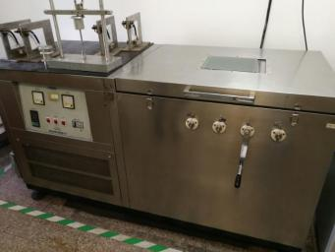 | 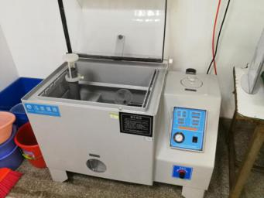
Low temperature winding tester低温绕卷实验机） | Salt spray corrosion test box（盐雾腐蚀实验箱）
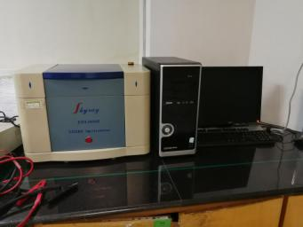 | 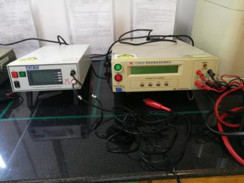
EDXRF SPECTROMETER（ROHS检测机） | Insulation resistance test instrument and Grounding resistance tester（绝缘电阻测试仪和接地电阻测试仪）
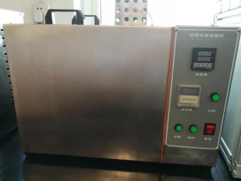 | 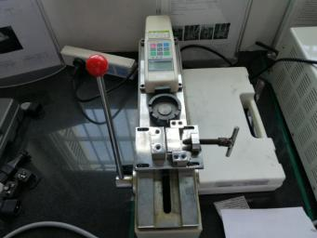
Oil bath tester（恒温油槽测试仪） | Push and pull meter（推拉力计）
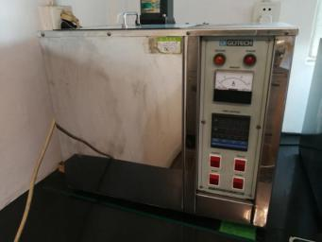 | 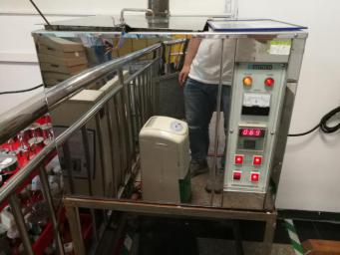
Heat stability tester（热稳定性测试仪） | Water bath tester（恒温水槽测试）
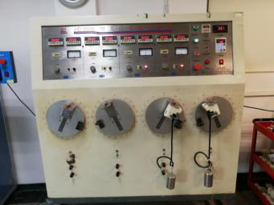 | 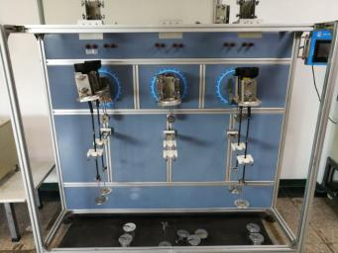
Bending test machine（弯曲测试机）
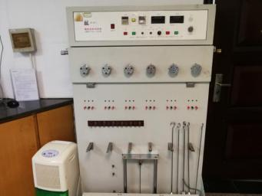 | 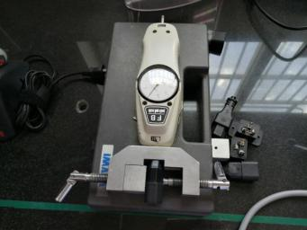
Abrupt pull tester（插头突拉测试机） | Coupling insert-pull tester（连接器插拔力测试仪）
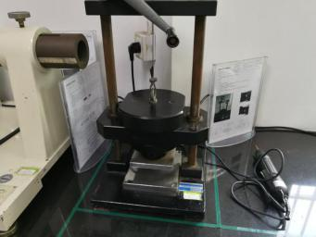 | 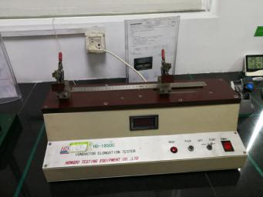
Compressor tester(压缩实验机) | Copper wire elongation tester(铜丝伸长率测试)
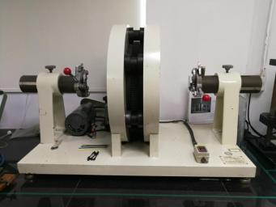 | 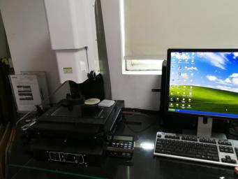
PSE flexible tester（PSE曲饶测试机） | Projector（投影仪）
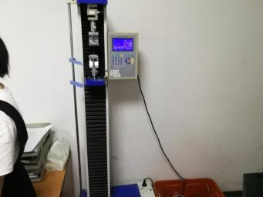 | 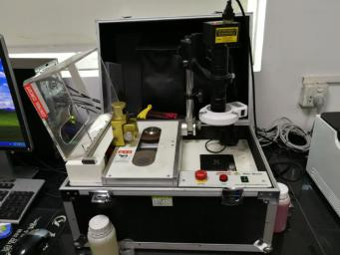
Microcomputer tensile tester（微电脑拉力试验机） | Cross section projection instrument for terminal riveting（端子铆接横截面投影）
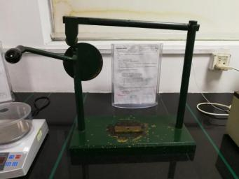 | 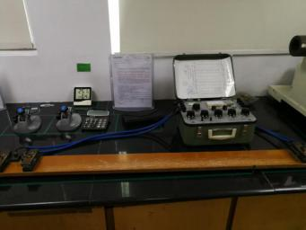
Cord retention and torque tesrer（保持力及力矩测试仪） | Conductor resistance tester（导体电阻测试仪器）
workshop
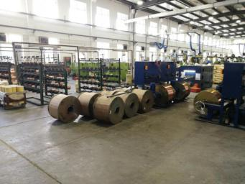 | 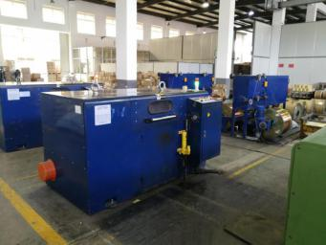
Winding machine（绕线机） | Winding machine（绕线机）
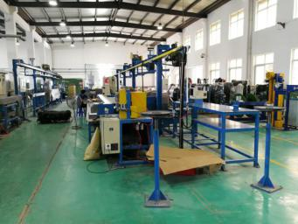 | 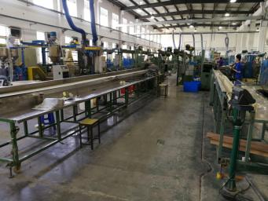
wire cutting done on automated machines
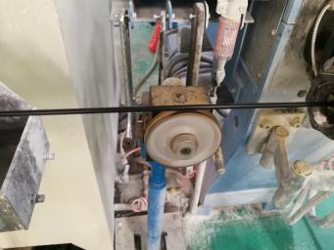 | 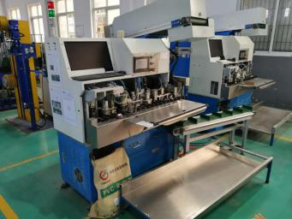
Wire printing | Automatic riveting machine（全自动铆接机）
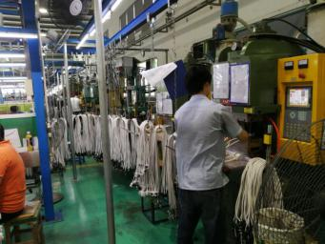 | 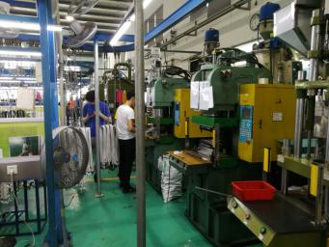
Plug injection molding zone
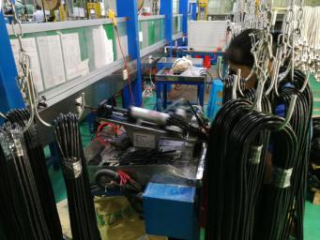 | 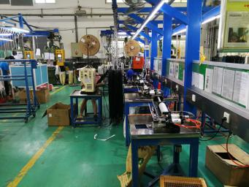
Semi-automatic stripper area
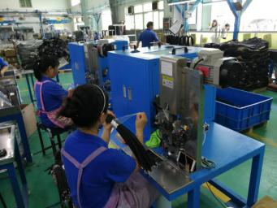 | 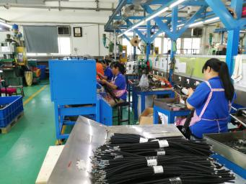
Automatic riveting machine
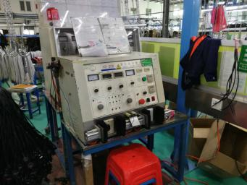 | 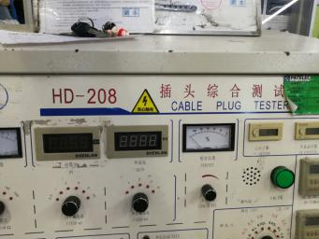
Cable Plug tester
Warehouse
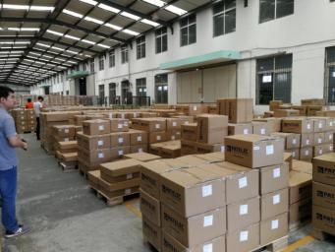 | 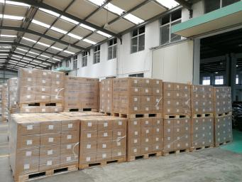
Finished Product warehouse
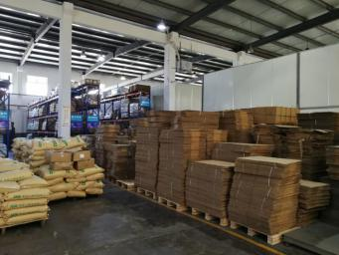 | 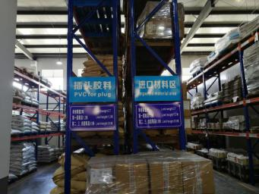
Packing material area | PVC foe plug and Imported material area
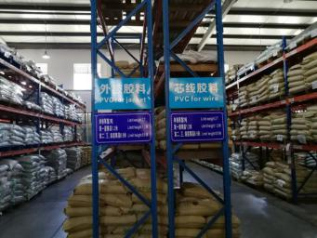 | 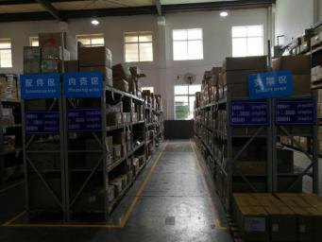
PVC for jacket and PVC for wire | Accessories、Housing and Insert area
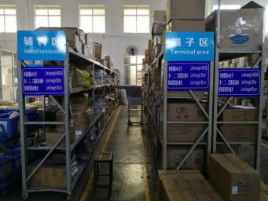
Assistant material and terminal area

